**Master Thesis Topic: Evaluation of Computation Offloading Decision Making Model in BBR-enabled Edge Computing**

**Name:** Rohit Jain

**Matriculation Number:** 2512376

**Department:** FB20

**Start date:** TBD

**Supervisors:** [1] Prof. Dr. Max Mühlhäuser, [2] Florian Brandherm

**Introduction & Motivation:**

TCP congestion control has been historically a problem of great interest for the Internet since 1980s. Today’s most widely used congestion control mechanism – TCP CUBIC relies on loss of packets to identify congestion problem. However, this technique does not scale well with network throughput for varying large and small buffer queue sizes. In 2016 Google came up with Bottleneck Bandwidth and Round-trip propagation time (BBR) protocol, which used a different approach – monitoring maximum recent network bandwidth and minimum recent round-trip delay to make a model, which helps to decide the optimal sending data rate and amount of data in flight at every moment during transmission, thereby reducing overall communication latency to an optimal minimum.

This new protocol projected promising results, and therefore it gathered much interest from a wide range of researchers and developers’ community for further testing (benchmarking and comparisons) and application (Wired and Wireless Networks) and also led to advancement in different forms of variations like BBR+, BBR v2, BBRfi.

The characteristics of BBR makes it relevant for application in Edge Computing as one of core goals for achieving low latency communication between Edge Client, Edge Server and/or Remote Server / Cloud Service. At the moment there is a lot of variability in results while comparing performance between traditional TCP CUBIC and BBR with respect to Wireless Communication over Wifi, 4G and 5G Networks.

This along with decision model for computation offloading in Mobile Edge Computing represents a good research gap for further study.

**Goals and Approach:**

In this Master’s thesis we aim to test and evaluate the computational offloading decision making between edge client and remote server based on Round Trip Time (RTT) and respective processing time at client and server, for the purpose of image labelling of objects, with pictures captured through camera at the edge client. We are assuming and anticipating processing time (image labelling) at edge client and remote server to be within a defined maximum bounded time range, through the use of pretrained neural models available in form of ready to use API in python. We aim to optimize overall latency and RTT through use of Bottleneck Bandwidth and Round-trip propagation time (BBR) protocol. During the test runs we would be collecting statistics using BBR and we will estimate the current Bandwidth and RTT, among some other parameters. These statistics will enable us to build computation offloading decision model with which we would be able to predict and anticipate if image labelling activity can happen faster on edge client or remote server in cloud.

**Tools and Techniques:**

Network Performance Measurement & Tuning Tool: iPerf (Linux), Linux Kernel development for BBR with C++, Image labelling application on Edge Client & Remote Server with Python, RTT & Processing Time measurement and recording at Edge Client & Remote Server.

In order to get realistic measurements of RTT values, Remote server is planned to deployed with AWS at a geographically far off location.

Choice of BBR variant is still under review pending further literature research.

**First Sketch of the Idea:**

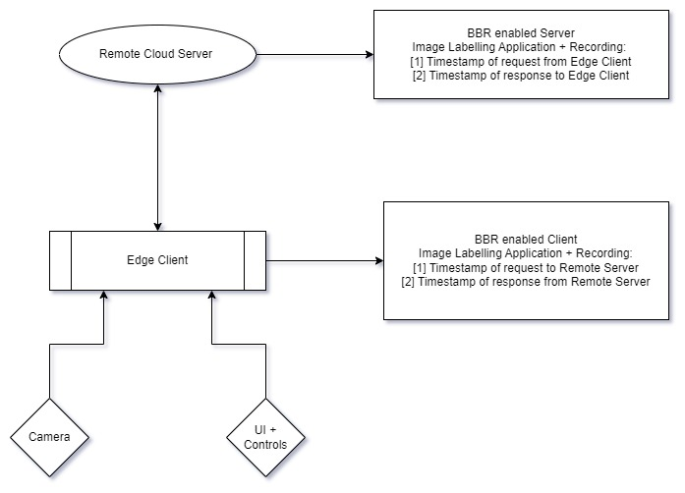

**Related Work:**

The initial idea for BBR protocol has been discussed in the following paper, which serves as the starting point for further research:

[1] Cardwell, N., Cheng, Y., Gunn, C.S., Yeganeh, S.H. and Jacobson, V., 2017. BBR: congestion-based congestion control. Communications of the ACM, 60(2), pp.58-66.

This paper serves for better understanding of BBR in terms of core mechanism and metrics:

[2] Scholz, D., Jaeger, B., Schwaighofer, L., Raumer, D., Geyer, F. and Carle, G., 2018, May. Towards a deeper understanding of TCP BBR congestion control. In 2018 IFIP networking conference (IFIP networking) and workshops (pp. 1-9). IEEE.

The next paper talks about comparison of different versions of BBR and performance statistics:

[3] C. A. Grazia, N. Patriciello, M. Klapez and M. Casoni, "BBR+: improving TCP BBR Performance over WLAN," ICC 2020 - 2020 IEEE International Conference on Communications (ICC), 2020, pp. 1-6, doi: 10.1109/ICC40277.2020.9149220.

**Evaluation:**

We have a set of metric parameters which will enable us to test, evaluation and adjust our experimentation with different configurations of BBR[2]. These are as follows:

[1] Sending Rate & Throughput – Computation of average bit rate based on packet sizes of transmission and time interval / delay in between packets.

[2] Round Trip Time – Total amount of delay between the timestamp when Edge Client sends request to Remote Server and timestamp when Edge Client receives response from Remote Server with the result of image labelling.

[3] Retransmissions – Number of retransmission of packets before congestion happens.

[4] In flight data – Amount of data which is in network at any moment of time

[5] Image labelling processing time – Both on Edge client & Remote Server

**Initial Time Plan:**

|  |  |
| --- | --- |
| **Activity** | **Time Allocation** |
| Literature review | 8 weeks = 2 months |
| Initial design phase | 2 weeks = 0.5 months |
| Implementation, Testing & Results Acquisition | 6 weeks = 1.5 months |
| Report Writing | 6 weeks = 1.5 months |
| Final Revision and Correction | 2 weeks = 0.5 months |

**References:**

[1] Cardwell, N., Cheng, Y., Gunn, C.S., Yeganeh, S.H. and Jacobson, V., 2017. BBR: congestion-based congestion control. Communications of the ACM, 60(2), pp.58-66.

[2] Scholz, D., Jaeger, B., Schwaighofer, L., Raumer, D., Geyer, F. and Carle, G., 2018, May. Towards a deeper understanding of TCP BBR congestion control. In 2018 IFIP networking conference (IFIP networking) and workshops (pp. 1-9). IEEE.

[3] C. A. Grazia, N. Patriciello, M. Klapez and M. Casoni, "BBR+: improving TCP BBR Performance over WLAN," ICC 2020 - 2020 IEEE International Conference on Communications (ICC), 2020, pp. 1-6, doi: 10.1109/ICC40277.2020.9149220.

[4] <https://cloud.google.com/blog/products/networking/tcp-bbr-congestion-control-comes-to-gcp-your-internet-just-got-faster>

[5] Cardwell, N., Cheng, Y., Yeganeh, S.H., Swett, I., Vasiliev, V., Jha, P., Seung, Y., Mathis, M. and Jacobson, V., 2019, March. Bbrv2: A model-based congestion control. In Presentation in ICCRG at IETF 104th meeting.